**First Phase**

Home Page (Landing page)

* 1. Add banner manages by admin panel
  2. Search form where user search listing.
  3. Top right corner login/logout/registration/my account /dashboard
  4. Slider show manage by admin (add/edit/delete by admin user)

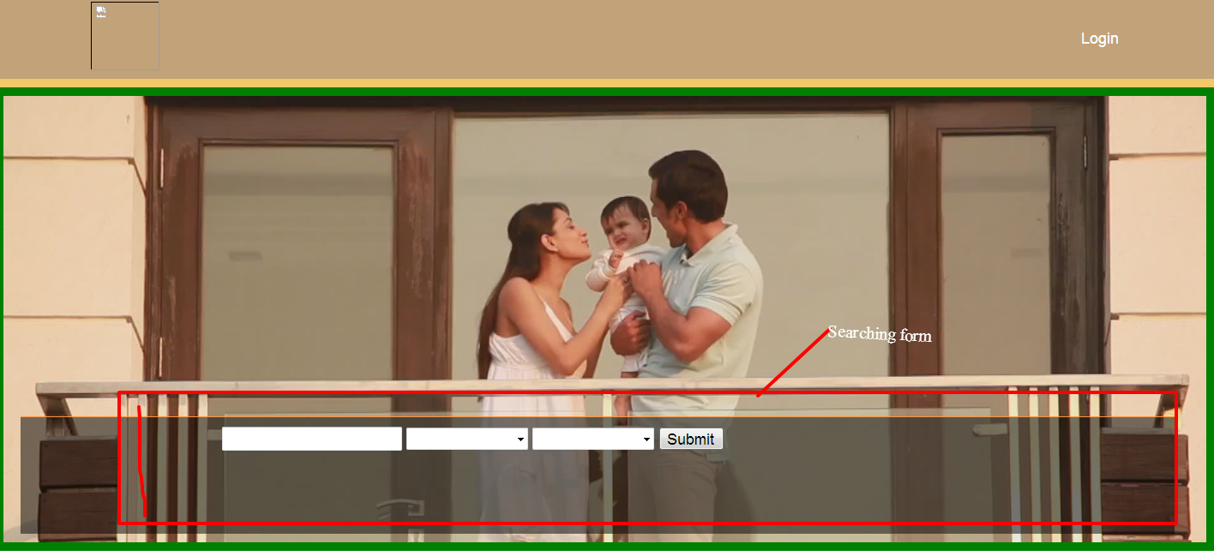

Searching result page

* 1. left site listing and right site map

1.6 Top of listing place filter which can sort all result

( 22-June Mentioned by Mohsin – Please state what are the filter options example as shows like budget , bhk etc)

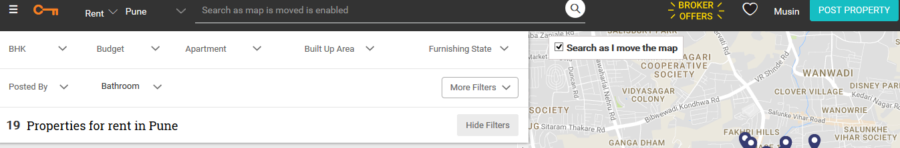

Map

* 1. Use google map with zooming, satellite, etc
  2. Map move left site listing shortlist
  3. Mouse over on marker summary show on popup

Listing

* 1. Show all searching result on page
  2. Listing page one or two line info and two button (contact seller and view details
  3. Add WISHLIST button, REPORT BUTON ,SHAREbutton marked in below picture
  4. After clicking of view detail pop show short summary of place.

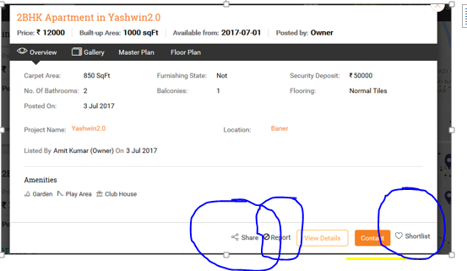

* 1. In short summary page bottom set detail information ( Mohsin 22 June put tracking feature on CONTACT SELLER button so we know how many buyers clicked to see the contact details see sample for quick view)
  2. Add Total Visitors list and total properties listed , total sellers contacted

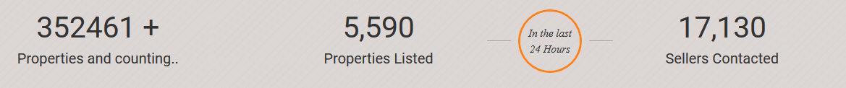

* 1. After clicking on contact seller form show and after fill form send email and thank you message show.

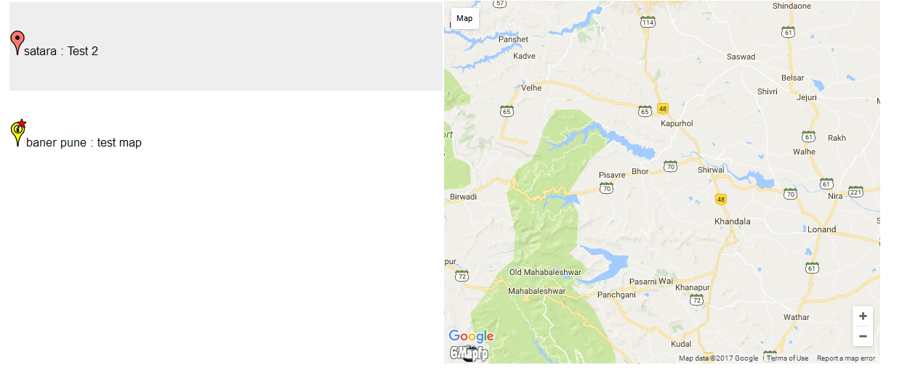

Contact seller form

* 1. Email, Phone and Name
  2. After submit form send email seller and admin. Store information admin site.

Users

* 1. Two type of user (admin/seller)
  2. Each User have my account section where user can change personal information and password
  3. Seller user only add/edit/delete place on my account dashboard.
  4. Seller dashboard where user see list of place which add by himself.
  5. Not need now Buyer user may be register using facebook account.(option) but still add the functionality

Form

* 1. Login form we all user login

Username, password

1.25Registration for (seller and buyer).

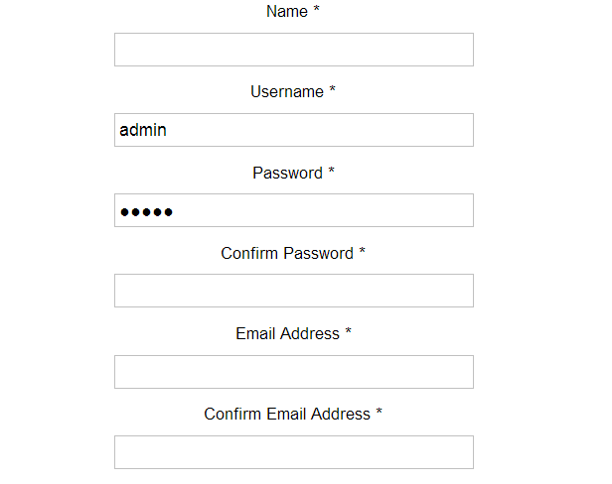

User registration form Added By mohsin

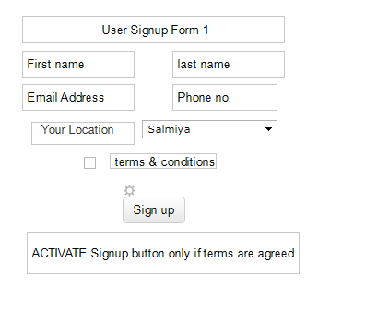

Contact seller.

Name, email

1. Place add form for seller user.

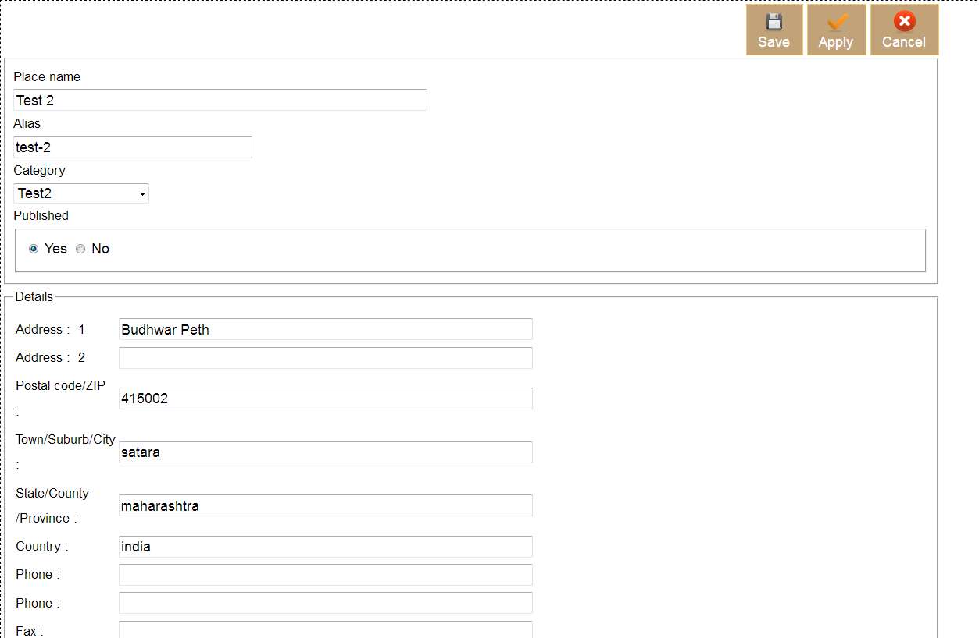

Added by Mohsin 22 june

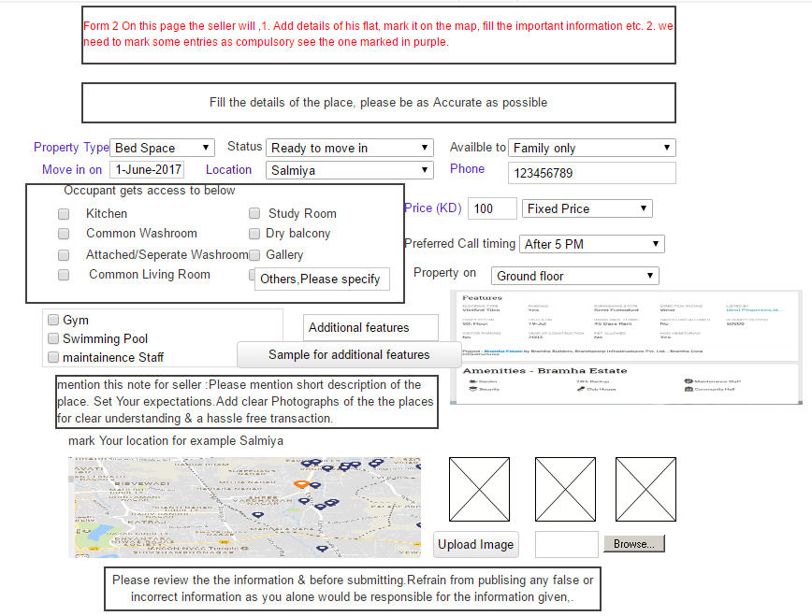

1. Contact us.

1 Name 2 Email 3 Message

Design

All form and page design. Responsive work on later phase.